A Project Report on

“AN ELECTRICITY LOAD FORECASTING ALGORITHM BASED ON KERNEL LASSO REGRESSION ”
Submitted to in partial fulfillment of the requirements for the award of the Degree of
BACHELOR OF TECHNOLOGY IN
ELECTRICAL AND ELECTRONICS ENGINEERING
Submitted by
RAVIKISHORE REDDY.J 20AK1A0220
CHAKRADHAR REDDY.P 20AK1A0204
HARSHITHA.A 20AK1A0208
RUPESH.K 20AK1A0223
Under the esteemed guidance of
Dr. R. MURUGESAN, M . tech., Ph. d.,
Associate Professor,
Dept of EEE


DEPARTMENT OF ELECTRICAL AND ELECTRONICS ENGINEERING
ANNAMACHARYA INSTITUTE OF TECHNOLOGY AND SCIENCES, TIRUPATI
(Autonomous)
Approved by AICTE NEW DELHI & Permanent Affiliation to JNTUA. Anantapuram Recognized under section 2 (f)& 12 (B) of UGCC Act of 1956.
Three B. Tech programmes CSE,ECE & CIVIL are accredited by National Board of Accreditation (NBA). New Delhi; Accredited by NAAC-'A' Grade, Bangalore: •A • Grade awarded by AP knowledge Mission; Accredited by the Institution of Engineers IE(I), Kolkata
Venkatapuram(V), Karakambadi Road, Renigunta (M).
TIRUPATI- 517520.
2023-2024

ANNAMACHARYA INSTITUTE OF TECHNOLOGY AND SCIENCES,
TIRUPATI (AUTONOMOUS)
DEPARTMENT OF ELECTRICAL AND ELECTRONICS ENGINEERING

CERTIFICATE

This is to certify that the project work entitled, “SMART ENERGY ANALYTICS - KERNAL LASSO REGRESSION FOR ACCURATE ELECRTICITY LOAD PROJECTIONS” done by J. RAVIKISHORE REDDY, P.CHAKRADHAR REDDY, A.HARSHITHA, K.RUPESH bearing Roll no(s)
20AK1A0220, 20AK1A0204, 20AK1A0208, 20AK1A0223 in partial fulfilment of the requirements for the Degree of BACHELOR OF TECHNOLOGY in ELECTRICAL AND ELECTRONICS ENGINEERING, is a record of bonafied work carried out by them.

UNDER GUIDANCE, HEAD OF THE DEPARTMENT, Dr. R. MURGESAN, M. Tech., Ph. d., DR. R. MURGESAN, M. Tech, Ph. d.,
Associate Professor, Associate Professor,
Dept of EEE, Dept of EEE,
A.I.T.S., Tirupati. A.I.T.S., Tirupati.

Submitted for the Viva-Voice held on:

INTERNAL EXAMINER EXTERNAL EXAMINER

ACKNOWLEDGEMENT

The needs and deeds of a particular person are only satisfied with the support and endurance of many. We take this opportunity to thank almighty first for giving our health and patience in completing assigned jobs.

Our heartful thanks to the guide Dr. R. MURUGESAN, _{M.} _{Tech}, Ph .D. Associate professor in Department of EEE, Annamacharya Institute of Technology and Sciences. For his valuable guidance and suggestions in analysis and testing throughout the period, till the end of project work completion.

Our special thanks to Dr. R. MURGESAN, _{M.} _{Tech,} _{Ph.D}. Head of the Department of Electrical and Electronics Engineering during the progress of project work. For his timely suggestions and help in spite of his busy schedule.

We wish to express our sincere gratitude to Dr. C. NADHAMUNI REDDY, _{M.} _{Tech.,} _{Ph.D}. Principal, Annamacharya Institute of Technology and Sciences for his consistent help and encouragement to complete the project work.

We would like to express our grateful and sincere thanks to Dr. C. GANGI REDDY honorary secretary, Annamacharya Education Trust for providing all the necessary facilities during the course of study.

We wish to convey our gratitude and express sincere thanks to all D.C (Department committee) and P.R.C (Project Review Committee) members for their support and cooperation rendered for successful submission of my project work.

Finally, we would like to express our sincere thanks to faculty members of E.E.E Department, Lab Technicians, and friends one and all that has helped me to complete the project work successfully.

As a gesture of respect for our family members and for the support we received from them.

Project Associates

RAVIKISHORE REDDY.J 20AK1A0220

CHAKRADHAR REDDY.P 20AK1A0204

HARSHITHA.A 20AK1A0208

RUPESH.K 20AK1A0223
DECLARATION

We J. RAVIKISHORE REDDY (20AK1A0220), P. CHAKRADHAR REDDY (20AK1A0204), A. HARSHITHA (20AK1A0208), K. RUPESH (20AK1A0223) studying final year
B.Tech in Department of Electrical and Electronics Engineering of ANNAMACHARYA INSTITUTE OF TECHNOLOGY AND SCIENCES. We have registered for the final year Project entitled “SMART ENERGY ANALYTICS - KERNAL LASSO REGRESSION FOR ACCURATE ELECRTICITY LOAD PROJECTIONS” submitted for the B. Tech degree under the guidance of Dr. R. MURGESAN M. Tech.,Ph. D, and we promise to meet all the mandatory requirements as a specified by the project review committee. We declare that we will not hold the college, the department, and the lectures responsible for the outcome of our project result.

RAVIKISHORE REDDY.J (20AK1A0220)
CHAKRADHAR REDDY.P (20AK1A0204)
HARSHITHA .A (20AK1A0208)
RUPESH.K (20AK1A0223)

ABSTRACT
Electricity load forecasting is essential for ensuring the safe and cost-effective operation of power grids, and addressing the challenges posed by higher-dimensional electricity load data is a crucial aspect of this endeavor. Traditional linear regression algorithms often fall short in capturing the intricate patterns present in such datasets. To overcome this limitation, this paper proposes an innovative approach by integrating the kernel function into the Lasso linear regression method.
The kernel function serves as a transformative tool, enabling the mapping of data into a high-dimensional space. This extension empowers the linear method to effectively handle non-linear relationships within the dataset, thus enhancing its adaptability to complex, multidimensional electricity load patterns. The integration of the kernel function into Lasso regression represents a novel step towards addressing the shortcomings of conventional linear models when faced with non-linearity.
The focus of this study is on non-time series data, a context in which linear regression models often encounter challenges. By applying the kernel function to Lasso regression, this research aims to provide a comprehensive solution for non-linear regression analysis in electricity load forecasting. The study employs a dataset consisting of 96-point electricity load measurements from users in Shanghai, spanning 851 consecutive days since 2014.
The experimental results demonstrate the superior predictive performance of kernel Lasso regression over traditional Lasso regression. The evaluation metrics, including minimum mean square error and minimum average percentage error, attest to the efficacy of the proposed method. The findings emphasize the method's capability to achieve more accurate and reliable power load forecasting results, especially in scenarios with higher-dimensional and non-linear electricity load data.
Beyond its immediate application to electricity load forecasting, the integration of kernel Lasso regression into non-linear regression analysis holds promise for diverse fields. This research contributes to the advancement of predictive modeling methodologies, showcasing the potential for broader applicability in domains where non-linear relationships play a significant role. The results presented in this study pave the way for further exploration, refinement, and adoption of advanced regression techniques in multidimensional datasets, fostering resilience and efficiency in power grid operations.

CHAPTER-1

INTRODUCTION

Accurate and reliable electricity load forecasting can provide reliable decision-making basis for electricity system planning and operation and provide guarantee for the safe and economic operation of electricity system. How to improve forecasting accuracy has always been a hot research topic at home and abroad. Lasso was proposed by Tibshirani in 1996, and it has been widely used because of its variable selection ability. For lasso method, algorithms such as iteratively reweighted least squares (IRLS), ε-boosting, least angle regression (Lars) and piecewise linear have been proposed [3-5], which makes the calculation of lasso more and more efficient. However, in practical applications, the prediction effect of lasso is poor for non-linear problems. How to improve the performance of lasso in non-linear problems is a problem which is worth studying.
Furthermore, the demand for accurate electricity load forecasting stems from its crucial role in ensuring the safe and economical operation of the electricity system. Reliable forecasts serve as a foundation for strategic decision-making, aiding in the optimization of resource allocation, grid planning, and overall system reliability. As the energy landscape undergoes dynamic changes with the integration of renewable energy sources and the rise of smart grids, the need for advanced forecasting techniques becomes even more pronounced.
While Lasso regression has demonstrated success in linear scenarios and is celebrated for its variable selection capabilities, its limitations in handling non-linear relationships pose a significant challenge. The energy domain, characterized by intricate and evolving patterns, often exhibits non-linear behaviors that conventional linear models struggle to capture accurately. Overcoming these limitations is imperative for harnessing the full potential of Lasso regression in the complex and dynamic context of electricity load forecasting.
In response to the shortcomings of Lasso in non-linear scenarios, researchers have embarked on exploring innovative solutions, including the integration of kernel methods. The introduction of kernel functions into Lasso regression allows for the transformation of feature spaces, enabling the model to better capture intricate non-linear dependencies within the data. This amalgamation of Lasso and kernel methods provides a promising avenue for improving forecasting accuracy, particularly when confronted with the inherent non-linearities in electricity load data.
In this evolving landscape, the quest for enhanced forecasting methodologies extends beyond algorithmic improvements. It involves a holistic approach that considers the integration of domain knowledge, the incorporation of advanced data preprocessing techniques, and the utilization of diverse data sources. Addressing these facets is integral to fortifying the forecasting capabilities of Lasso regression and ensuring its adaptability to the challenges posed by modern, complex energy systems. Consequently, this research contributes to advancing the state-of-the-art in electricity load forecasting, with potential implications for broader applications in energy planning and management.
CHAPTER-2

SYSTEM TEST
The purpose of testing is to discover errors. Testing is the process of trying to discover every conceivable fault or weakness in a work product. It provides a way to check the functionality of components, sub assemblies, assemblies and/or a finished product It is the process of exercising software with the intent of ensuring that the Software system meets its requirements and user expectations and does not fail in an unacceptable manner. There are various types of test. Each test type addresses a specific testing requirement.
TYPES OF TESTS
Unit testing
Unit testing involves the design of test cases that validate that the internal program logic is functioning properly, and that program inputs produce valid outputs. All decision branches and internal code flow should be validated. It is the testing of individual software units of the application .it is done after the completion of an individual unit before integration. This is a structural testing, that relies on knowledge of its construction and is invasive. Unit tests perform basic tests at component level and test a specific business process, application, and/or system configuration. Unit tests ensure that each unique path of a business process performs accurately to the documented specifications and contains clearly defined inputs and expected results.
Integration testing
Integration tests are designed to test integrated software components to determine if they actually run as one program. Testing is event driven and is more concerned with the basic outcome of screens or fields. Integration tests demonstrate that although the components were individually satisfaction, as shown by successfully unit testing, the combination of components is correct and consistent. Integration testing is specifically aimed at exposing the problems that arise from the combination of components.
Functional test
Functional tests provide systematic demonstrations that functions tested are available as specified by the business and technical requirements, system documentation, and user manuals.
Functional testing is centered on the following items:
Valid Input : identified classes of valid input must be accepted.
Invalid Input : identified classes of invalid input must be rejected.
Functions : identified functions must be exercised.
Output : identified classes of application outputs must be exercised.
Systems/Procedures : interfacing systems or procedures must be invoked.
Organization and preparation of functional tests is focused on requirements, key functions, or special test cases. In addition, systematic coverage pertaining to identify Business process flows; data fields, predefined processes, and successive processes must be considered for testing. Before functional testing is complete, additional tests are identified and the effective value of current tests is determined.
System Test
System testing ensures that the entire integrated software system meets requirements. It tests a configuration to ensure known and predictable results. An example of system testing is the configuration oriented system integration test. System testing is based on process descriptions and flows, emphasizing pre-driven process links and integration points.
White Box Testing
White Box Testing is a testing in which in which the software tester has knowledge of the inner workings, structure and language of the software, or at least its purpose. It is purpose. It is used to test areas that cannot be reached from a black box level.
Black Box Testing
Black Box Testing is testing the software without any knowledge of the inner workings, structure or language of the module being tested. Black box tests, as most other kinds of tests, must be written from a definitive source document, such as specification or requirements document, such as specification or requirements document. It is a testing in which the software under test is treated, as a black box .you cannot “see” into it. The test provides inputs and responds to outputs without considering how the software works.
Unit Testing
Unit testing is usually conducted as part of a combined code and unit test phase of the software lifecycle, although it is not uncommon for coding and unit testing to be conducted as two distinct phases.
Test strategy and approach
Field testing will be performed manually and functional tests will be written in detail.
Test objectives
All field entries must work properly.
Pages must be activated from the identified link.
The entry screen, messages and responses must not be delayed.

Features to be tested
Verify that the entries are of the correct format
No duplicate entries should be allowed
All links should take the user to the correct page.
Integration Testing
Software integration testing is the incremental integration testing of two or more integrated software components on a single platform to produce failures caused by interface defects.
The task of the integration test is to check that components or software applications, e.g. components in a software system or – one step up – software applications at the company level – interact without error.
Test Results: All the test cases mentioned above passed successfully. No defects encountered.
Acceptance Testing
User Acceptance Testing is a critical phase of any project and requires significant participation by the end user. It also ensures that the system meets the functional requirements.
Test Results: All the test cases mentioned above passed successfully. No defects encountered.

Sample Test Cases

S.no | Test Case | Excepted Result | Result | Remarks(IF Fails)
1 | User Register | If User registration successfully. | Pass | If already user email exist then it fails.
2 | User Login | If Username and password is correct then it will getting valid page. | Pass | Un Register Users will not logged in.
3 | machine learning algorithm | Here we used machine learning algorithm. | Pass | The request will be not accepted other wise its failed
4 | Machine learning results | Machine learning results calculated and displayed | Pass | Results not true failed
5 | Predict results | predict results calculated and displayed | Pass | data is consider for testing
6 | MAPE, MSE | MSE and MAPE will be displayed by the user | Pass | Results not true failed
7 | Prediction results | Prediction results calculated and displayed | Pass | Results not true failed
8 | forecast | forecast results calculated and displayed | Pass | MAE and MSE not displayed failed
9 | Admin login | Admin can login with his login credential. If success he get his home page | Pass | Invalid login details will not allowed here
10 | Admin can activate the register users | Admin can activate the register user id | Pass | If user id not found then it won’t login.

CHAPTER-3

SOURCE CODE

User side views.py
from django.shortcuts import render,HttpResponse
from django.contrib import messages
from .forms import UserRegistrationForm
from .models import UserRegistrationModel
from django.conf import settings
import os

# Create your views here.
def UserRegisterActions(request):
if request.method == 'POST':
form = UserRegistrationForm(request.POST)
if form.is_valid():
print('Data is Valid')
form.save()
messages.success(request, 'You have been successfully registered')
form = UserRegistrationForm()
return render(request, 'UserRegistrations.html', {'form': form})
else:
messages.success(request, 'Email or Mobile Already Existed')
print("Invalid form")
else:
form = UserRegistrationForm()
return render(request, 'UserRegistrations.html', {'form': form})
def UserLoginCheck(request):
if request.method == "POST":
loginid = request.POST.get('loginname')
pswd = request.POST.get('pswd')
print("Login ID = ", loginid, ' Password = ', pswd)
try:
check = UserRegistrationModel.objects.get(loginid=loginid, password=pswd)
status = check.status
print('Status is = ', status)
if status == "activated":
request.session['id'] = check.id
request.session['loggeduser'] = check.name
request.session['loginid'] = loginid
request.session['email'] = check.email
print("User id At", check.id, status)
return render(request, 'users/UserHome.html', {})
else:
messages.success(request, 'Your Account Not at activated')
return render(request, 'UserLogin.html')
except Exception as e:
print('Exception is ', str(e))
pass
messages.success(request, 'Invalid Login id and password')
return render(request, 'UserLogin.html', {})
def UserHome(request):
return render(request, 'users/UserHome.html', {})

def usersViewDataset(request):
dataset = os.path.join(settings.MEDIA_ROOT, 'Shanghai_data.csv')
import pandas as pd
df = pd.read_csv(dataset)
df['nextDay'] = df.mean(numeric_only=True, axis=1)
df = df.to_html(index=None)
return render(request, 'users/viewData.html',{'data': df})

def lassoResults(request):
from .utility import LassoUtility
data = LassoUtility.simple_linear_regression()
ls_mae,ls_mse = LassoUtility.lasso_regression()
l_mae,l_mse = LassoUtility.kernel_my_lasso()
return render(request, 'users/ml_results.html',{'ls_mae': ls_mae,'ls_mse': ls_mse,'l_mae': l_mae, 'l_mse': l_mse})

def userPrediction(request):
if request.method=='POST':
day1 = float(request.POST.get('day1'))
day2 = float(request.POST.get('day2'))
day3 = float(request.POST.get('day3'))
day4 = float(request.POST.get('day4'))
day5 = float(request.POST.get('day5'))
day6 = float(request.POST.get('day6'))
day7 = float(request.POST.get('day7'))
model_file = os.path.join(settings.MEDIA_ROOT, 'model.alex')
test_set = [day1,day2,day3,day4,day5,day6,day7]
import pickle
model = pickle.load(open(model_file,'rb'))
pred = model.predict([test_set])
print("===>",pred)
return render(request, 'users/predictForm.html', {'pred': pred})
else:
return render(request, 'users/predictForm.html',{})

def userForeCast(request):
from .utility.forecastanalysis import start_forecasting
forecast_values = start_forecasting()
pred_ci = forecast_values.to_html
return render(request, 'users/forecast.html',{'data': pred_ci})

Base.html:
{% load static %}
<!doctype html>
<html>
<head>
<meta charset="utf-8">
<meta name="viewport" content="width=device-width, maximum-scale=1">
<title>Electricity Forecasting</title>
<link rel="icon" href="{%static 'favicon.png'%}" type="image/png">
<link href="{%static 'css/bootstrap.min.css'%}" rel="stylesheet" type="text/css">
<link href="{%static 'css/style.css'%}" rel="stylesheet" type="text/css">
<link href="{%static 'css/font-awesome.css'%}" rel="stylesheet" type="text/css">
<link href="{%static 'css/animate.css'%}" rel="stylesheet" type="text/css">

</head>
<body>

<!--Header_section-->
<header id="header_wrapper">
<div class="container">
<div class="header_box">
<div class="logo"><a href="#"><h2>Electricity Forecasting</h2></a></div>
<nav class="navbar navbar-inverse" role="navigation">
<div class="navbar-header">
<button type="button" id="nav-toggle" class="navbar-toggle" data-toggle="collapse"
data-target="#main-nav"><span class="sr-only">Toggle navigation</span> <span
class="icon-bar"></span> <span class="icon-bar"></span> <span class="icon-bar"></span>
</button>
</div>
<div id="main-nav" class="collapse navbar-collapse navStyle">
<ul class="nav navbar-nav" id="mainNav">
<li><a href="{%url 'index'%}">Home</a></li>
<li><a href="{%url 'UserLogin'%}">Login</a></li>
<li><a href="{%url 'AdminLogin'%}">Admin</a></li>
<li><a href="{%url 'UserRegister'%}">Registrations</a></li>
</ul>
</div>
</nav>
</div>
</div>
</header>
<!--Header_section-->
{%block contents%}

<!--Aboutus-->
{%endblock%}
<!--Footer-->
<footer class="footer_wrapper" id="contact">
<div class="container">
<div class="footer_bottom"><span>Copyright © 2023, Template by <a
href="#">Alex Corporations</a>. </span></div>
</div>
</footer>

<script type="text/javascript" src="{%static 'js/jquery-1.11.0.min.js'%}"></script>
<script type="text/javascript" src="{%static 'js/bootstrap.min.js'%}"></script>
<script type="text/javascript" src="{%static 'js/jquery-scrolltofixed.js'%}"></script>
<script type="text/javascript" src="{%static 'js/jquery.nav.js'%}"></script>
<script type="text/javascript" src="{%static 'js/jquery.easing.1.3.js'%}"></script>
<script type="text/javascript" src="{%static 'js/jquery.isotope.js'%}"></script>
<script type="text/javascript" src="{%static 'js/wow.js'%}"></script>
<script type="text/javascript" src="{%static 'js/custom.js'%}"></script>

</body>
</html>

Admins side views.py:
from django.shortcuts import render,HttpResponse
from django.contrib import messages
from users.models import UserRegistrationModel

# Create your views here.

def AdminLoginCheck(request):
if request.method == 'POST':
usrid = request.POST.get('loginid')
pswd = request.POST.get('pswd')
print("User ID is = ", usrid)
if usrid == 'admin' and pswd == 'admin':
return render(request, 'admins/AdminHome.html')
elif usrid == 'Admin' and pswd == 'Admin':
return render(request, 'admins/AdminHome.html')
else:
messages.success(request, 'Please Check Your Login Details')
return render(request, 'AdminLogin.html', {})

def AdminHome(request):
return render(request, 'admins/AdminHome.html')

def ViewRegisteredUsers(request):
data = UserRegistrationModel.objects.all()
return render(request, 'admins/RegisteredUsers.html', {'data': data})

def AdminActivaUsers(request):
if request.method == 'GET':
id = request.GET.get('uid')
status = 'activated'
print("PID = ", id, status)
UserRegistrationModel.objects.filter(id=id).update(status=status)
data = UserRegistrationModel.objects.all()
return render(request, 'admins/RegisteredUsers.html', {'data': data})

def adminResults(request):
from users.utility import LassoUtility
data = LassoUtility.simple_linear_regression()
ls_mae, ls_mse = LassoUtility.lasso_regression()
l_mae, l_mse = LassoUtility.kernel_my_lasso()
return render(request, 'admins/results.html',
{'ls_mae': ls_mae, 'ls_mse': ls_mse, 'l_mae': l_mae, 'l_mse': l_mse})

urls.py:

"""ElectricityForecasting URL Configuration

The `urlpatterns` list routes URLs to views. For more information please see:
https://docs.djangoproject.com/en/4.1/topics/http/urls/
Examples:
Function views
1. Add an import: from my_app import views
2. Add a URL to urlpatterns: path('', views.home, name='home')
Class-based views
1. Add an import: from other_app.views import Home
2. Add a URL to urlpatterns: path('', Home.as_view(), name='home')
Including another URLconf
1. Import the include() function: from django.urls import include, path
2. Add a URL to urlpatterns: path('blog/', include('blog.urls'))
"""
from django.contrib import admin
from django.urls import path

from django.contrib import admin
from django.urls import path
from ElectricityForecasting import views as mainView
from users import views as usr
from admins import views as admins

urlpatterns = [
path('admin/', admin.site.urls),
path("", mainView.index, name='index'),
path("index/", mainView.index, name="index"),
path("logout/", mainView.logout, name="logout"),
path("UserLogin/", mainView.UserLogin, name="UserLogin"),
path("AdminLogin/", mainView.AdminLogin, name="AdminLogin"),
path("UserRegister/", mainView.UserRegister, name="UserRegister"),

### User Side Views
path("UserRegisterActions/", usr.UserRegisterActions, name="UserRegisterActions"),
path("UserLoginCheck/", usr.UserLoginCheck, name="UserLoginCheck"),
path("UserHome/", usr.UserHome, name="UserHome"),
path("usersViewDataset/", usr.usersViewDataset, name="usersViewDataset"),
path("lassoResults/", usr.lassoResults, name="lassoResults"),
path("userPrediction/", usr.userPrediction, name='userPrediction'),
path("userForeCast/", usr.userForeCast, name="userForeCast"),

### Admin Side Views
path("AdminLoginCheck/", admins.AdminLoginCheck, name="AdminLoginCheck"),
path("AdminHome/", admins.AdminHome, name="AdminHome"),
path("ViewRegisteredUsers/", admins.ViewRegisteredUsers, name="ViewRegisteredUsers"),
path("AdminActivaUsers/", admins.AdminActivaUsers, name="AdminActivaUsers"),
path("adminResults/", admins.adminResults, name="adminResults"),

]

Index.html:

{%extends 'base.html'%}
{%load static%}
{%block contents%}
<!--Hero_Section-->
<section id="hero_section" class="top_cont_outer">
<div class="hero_wrapper">
<div class="container">
<div class="hero_section">
<div class="row">
<div class="col-lg-5 col-sm-7">
<div class="top_left_cont zoomIn wow animated">

<h2>An Electricity <strong> Load Forecasting Algorithm Based</strong> on Kernel Lasso Regression</h2>
<p>Electricity load forecasting is an important guarantee for the safe and economic operation of power grids. For electricity load data with higher dimensions, the forecasting effect of traditional linear regression algorithms are usually not ideal</p>
<!--<a href="#service" class="read_more2">Read more</a>-->
</div>
</div>
<div class="col-lg-7 col-sm-5">
<img src="{%static 'img/main_device_image.png'%}" class="zoomIn wow animated" alt=""/>
</div>
</div>
</div>
</div>
</div>
</section>
<!--Hero_Section-->

<section id="aboutUs"><!--Aboutus-->
<div class="inner_wrapper">
<div class="container">
<h2>About Us</h2>
<div class="inner_section">
<div class="row">
<div class=" col-lg-4 col-md-4 col-sm-4 col-xs-12 pull-right"><img
src="{%static 'img/about-img.jpg'%}" class="img-circle delay-03s animated wow zoomIn"
alt=""></div>
<div class=" col-lg-7 col-md-7 col-sm-7 col-xs-12 pull-left">
<div class=" delay-01s animated fadeInDown wow animated">
<h3>An Electricity Load Forecasting Algorithm Based on Kernel Lasso Regression</h3><br/>
<p>Electricity load forecasting is an important guarantee for the safe and economic operation of power grids. For electricity load data with higher dimensions, the forecasting effect of traditional linear regression algorithms are usually not ideal. Kernel function can be used to map the data to a high-dimensional space, so that can make the linear method handle non-linear data. This paper introduces the kernel function into the lasso linear regression method and applies it to non-linear problems to solve the regression analysis problem of non-time series data. Through using the 96-point electricity load data of users in Shanghai since 2014 for 851 consecutive days, the prediction effect of kernel lasso regression is better than lasso regression in terms of minimum mean square error and minimum average percentage error, which shows that the method can achieve better power load forecasting results.</p>
</div>
<div class="work_bottom"><span>Want to know more..</span> <a href="https://ieeexplore.ieee.org/document/9510772" target="_blank" class="contact_btn">Contact Us</a>
</div>
</div>

</div>

</div>
</div>
</div>
</section>
{%endblock%}
CHAPTER-4

IMPLEMENTATION:
MODULES:
User
Admin
Data Preprocessing
Machine learning Results

MODULES DESCRIPTION:
User:
The User can register the first. While registering he required a valid user email and mobile for further communications. Once the user register then admin can activate the user. Once admin activated the user then user can login into our system. User can upload the dataset based on our dataset column matched. For algorithm execution data must be in float format. Here we took electricity forecast dataset. User can also add the new data for existing dataset based on our Django application. User can click the Classification in the web page so that the data calculated MSE, MAPE based on the algorithms.

Admin:
Admin can login with his login details. Admin can activate the registered users. Once he activate then only the user can login into our system. Admin can view the overall data in the browser. Admin can click the Results in the web page so calculated MSE, MAPE based on the algorithms is displayed. All algorithms execution complete then admin can see the overall accuracy in web page.

Data Pre-processing:
A dataset can be viewed as a collection of data objects, which are often also called as a records, points, vectors, patterns, events, cases, samples, observations, or entities. Data objects are described by a number of features that capture the basic characteristics of an object, such as the mass of a physical object or the time at which an event occurred, etc. Features are often called as variables, characteristics, fields, attributes, or dimensions. The data pre-processing in this forecast uses techniques like removal of noise in the data, the expulsion of missing information, modifying default values if relevant and grouping of attributes for prediction at various levels.

machine learning Results:
Based on the split criterion, the cleansed data is split into 60% training and 40% test, then the dataset is subjected to Machine learning regressor such as, we used lasso, kernel lasso technique .The MAE and MAPE of the regressor was calculated and displayed in my results. The regressor which bags up the highest MAE and MAPE could be determined as the best classifier.

SCREEN SHOTS
Home page



Register Form

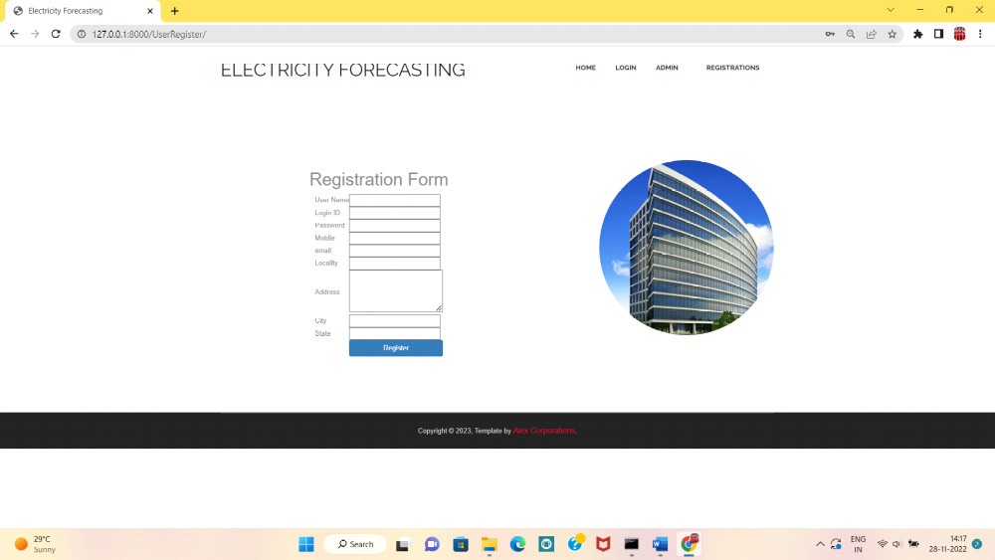

Admin Login Page
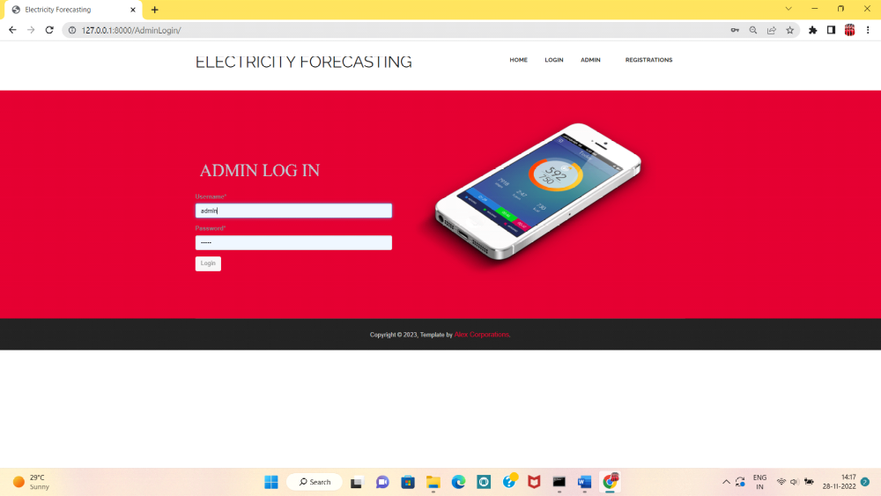

Admin home page:



Activate User

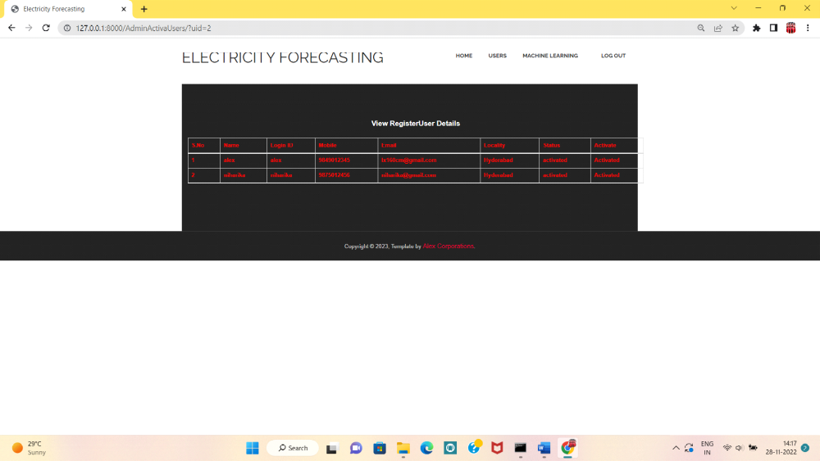

Admin side machine learning results:

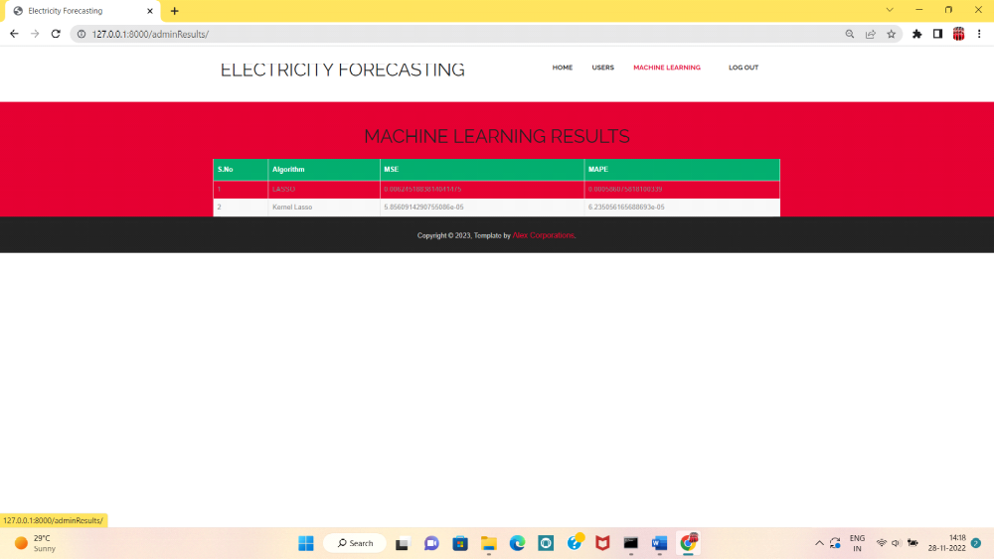

User Login Page:

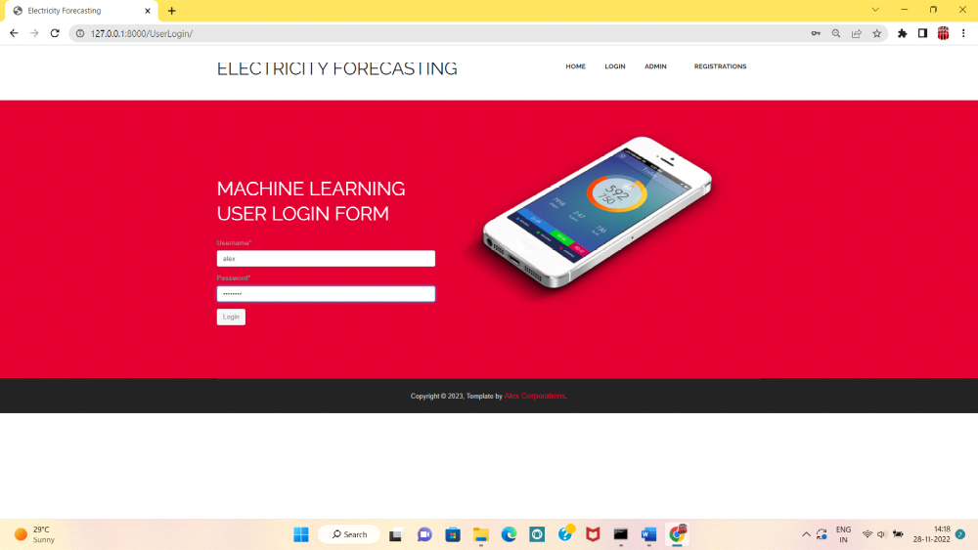

User Home Page:



User view data:

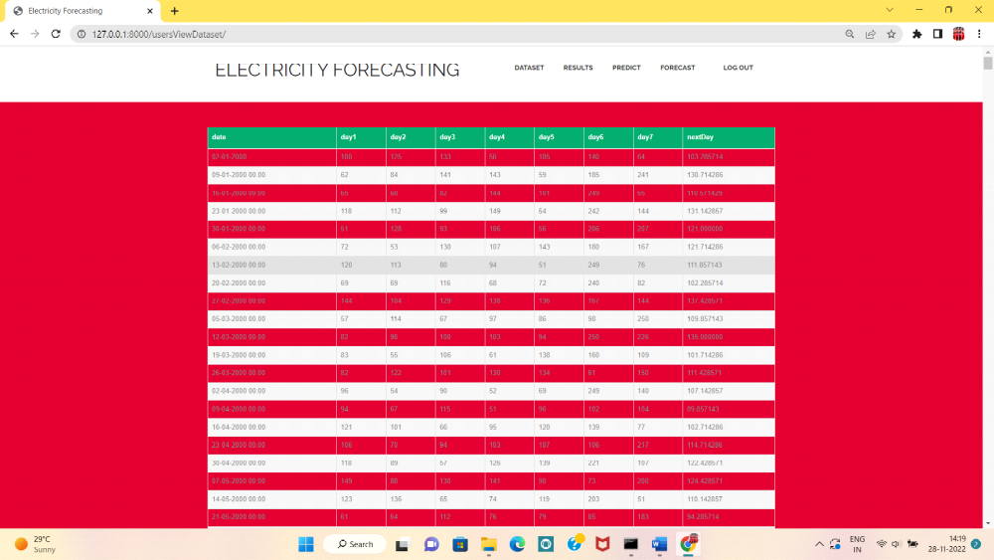

User side Machine learning results:

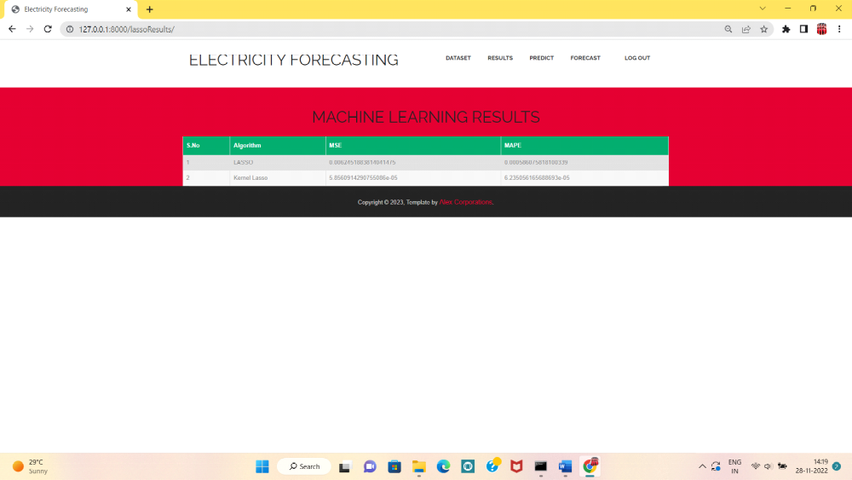

CHAPTER -5
RESULTS :

Predict:
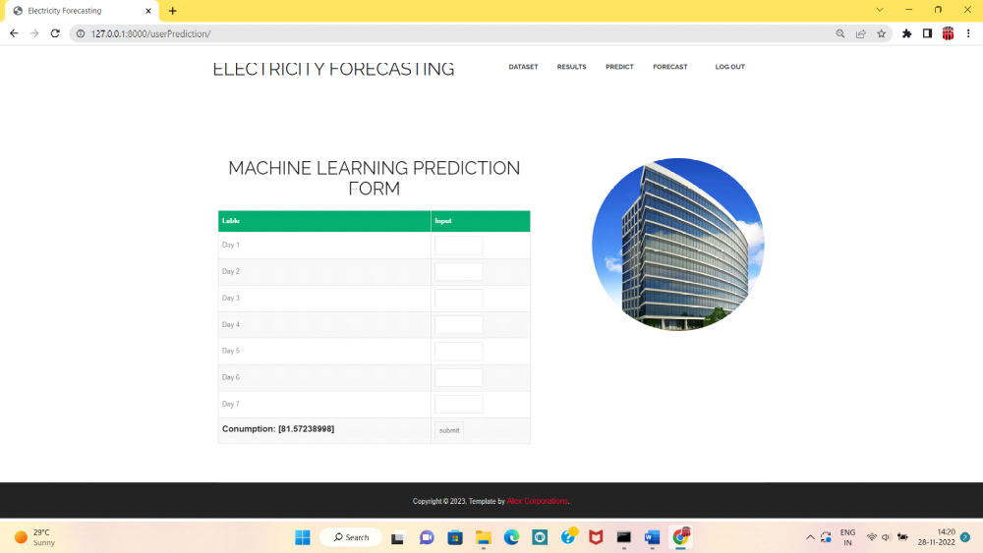

Forecast data:

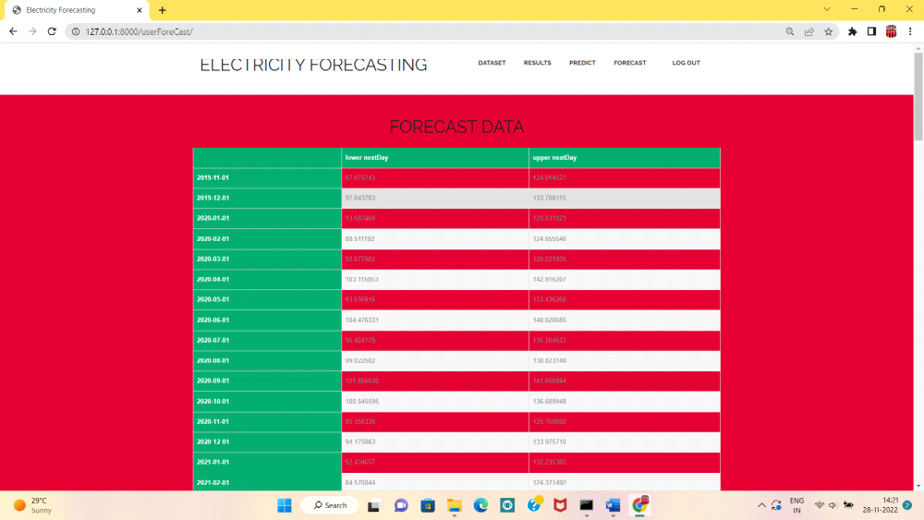

CONCLUSION
In conclusion, the application of Lasso regression proves to be an effective solution for addressing overfitting challenges associated with an excessive number of parameters in linear regression. Its ability to overcome matrix irreversibility through the introduction of the L1 norm as a regularization term in the cost function positions Lasso as a valuable tool for feature selection. The parameter λ facilitates fine-tuning, allowing the regression model to adapt and eliminate the influence of unimportant features, thereby enhancing model generalization.
The integration of the kernel method, founded on the notion that non-linearly separable data in low-dimensional space can be transformed into linearly separable data in high-dimensional space, introduces a powerful dimensionality-expanding technique. By applying the kernel function to Lasso linear regression, we extend its utility to non-linear regression problems. The transformation from a low-dimensional to a high-dimensional space allows for improved capturing of intricate relationships within the data, transforming originally linearly inseparable datasets into linearly separable ones.
In the specific context of electricity load forecasting, the experimental results using 96-point electricity load data from Shanghai users over 851 consecutive days showcase the superior predictive performance of kernel Lasso regression. The observed reduction in minimum mean square error and mean absolute percentage error underscores the efficacy of this approach in comparison to traditional Lasso regression.
Beyond the immediate benefits in load forecasting, the successful integration of kernel Lasso regression carries significant implications for various fields. Its applicability in non-linear regression scenarios suggests potential adoption in diverse domains where complex relationships exist. This research contributes to the ongoing discourse on refining regression methodologies, particularly for non-time series data, and opens avenues for further exploration.
Future research directions may include investigating the scalability of kernel Lasso regression to larger datasets, exploring the adaptability of the method to different industries, and refining the parameter tuning process for optimal model performance. As our understanding of advanced regression techniques continues to evolve, the findings presented here serve as a stepping stone towards more accurate and versatile predictive modeling in diverse applications.
窗体顶端

窗体底端

